General Transmission (Genstran) Product Identification

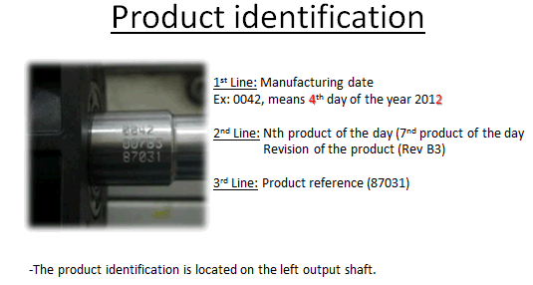

There may also be a decal on the top of the case that will give you the HOP part # of the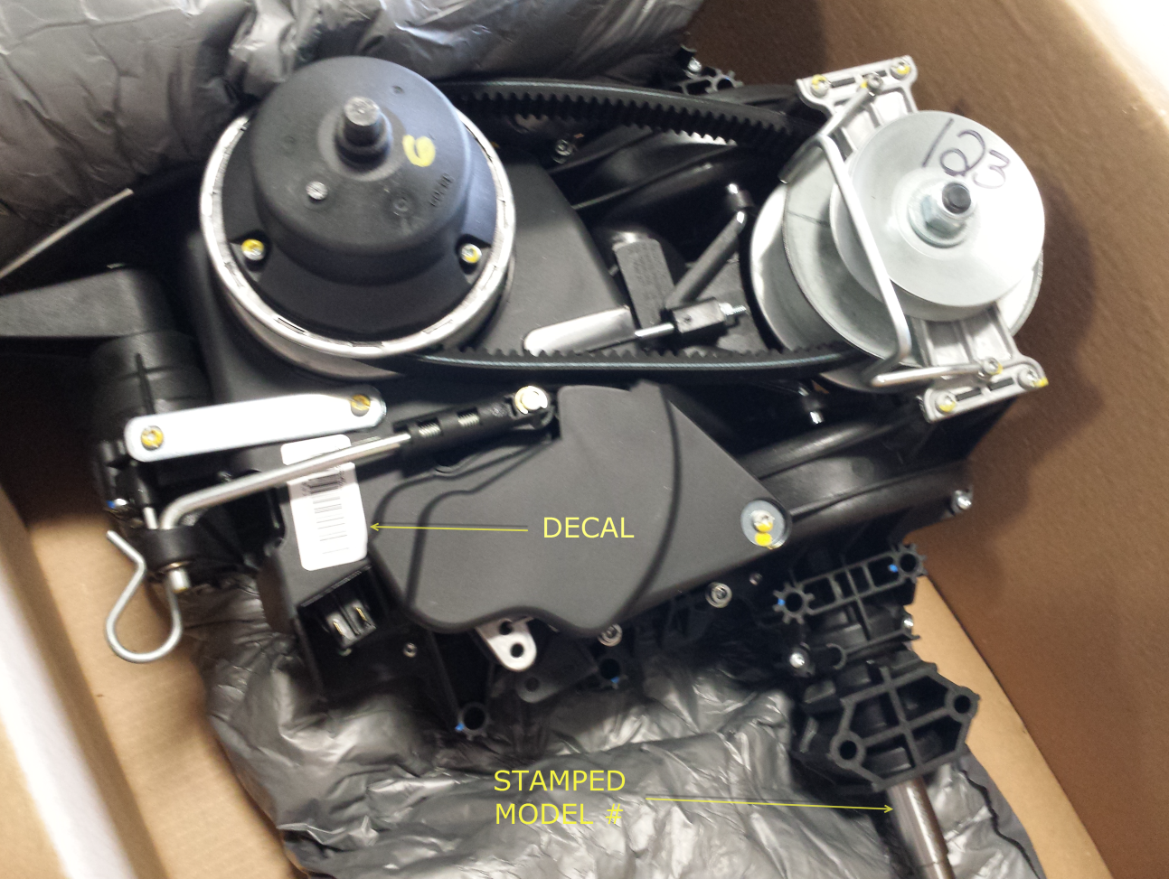 transmission